ALGERIAN DEMOCRATIC AND POPULAR REPUBLIC
MINISTRY OF HIGHER EDUCATION AND SCIENTIFIC RESEARCH
UNIVERSITY OF MOHAMED BOUDIAF - M’SILA
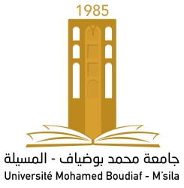

FACULTY OF SCIENCES

DEPARTMENT OF PHYSICS

N° : PhMat 07/2019

DOMAINE: SCIENCE OF MATTER
FIELD: physics
OPTION: physics of materials

Memory Submitted for Obtaining
Diploma of Academic Master
Prepared by: DJAAFER Hayat

TITLE:

Analytical Study of the Local Raw Materials Used in the Construction Bricks Industry

Defended on: 01/07/2019 before the jury composed of:

SAHNOUNE Foudil |  | University of Msila | Chairman
OUALI Ameur |  | University of Msila | Supervisor
HERAIZ Menad |  | University of Msila | Examiner

Academic Year : 2018/2019

