Band structure and optical spectra of double perovskite Cs₂AgBiBr₆ for solar cells performance
Adel Menedjhi^{1,2}, Nadir Bouarissa^{1,2,} , Salima Saib^{1,2} , Mustapha Boucenna² , Fadila Mezrag^{1,2}
¹Laboratory of Materials Physics and Its Applications, University of M'sila, 28000 M'sila, Algeria
² Physics Department, Faculty of Science, University of M'sila, 28000 M'sila, Algeria
Corresponding Author Email: n_bouarissa@yahoo.fr
Abstract
The present study reports on the electronic band structure and optical properties of Cs₂AgBiBr₆ double-perovskite material using a pseudopotential plane-wave method within the generalized gradient approximation. Our results show that Cs₂AgBiBr₆ has a good absorption in the visible spectrum region, nevertheless, it has an indirect band gap of magnitude of 1.32 eV. This limits its application in photovoltaic's. An alternative is proposed to overcome this shortcoming.
Keywords: Optoelectronic properties; Double perovskite materials; Solar cells.
PACS: 71.15.Dx; 71.20.-b.
- Introduction
Perovskite-type materials have attracted much attention in the field of photovoltaic devices. This is due to their important optical and electronic properties [1-5]. As a matter of fact, the power conversion efficiencies of perovskite solar cells were improved by about 20% in ten years, which makes them comparable with polycrystalline silicon solar cells.
Generally, perovskite solar cells with excellent performance are based on lead which is toxic and are instable [6]. This severely limits their applications in photovoltaics. To overcome this shortcoming, a new generation of perovskites materials such as Cs₂AgBiBr₆ was proposed [7-10]. These materials are inorganic, stable, and non toxic. Besides, they are regarded as useful materials for photovoltaic applications since they were reported to be successfully synthesized [11].
The fundamental properties of perovskite solar cell materials, mainly the electronic and optical properties play a crucial role in the design and fabrication of devices based on these materials. For that, the current contribution attempts to investigate the electronic band structure and absorption coefficient of the double perovskites material Cs₂AgBiBr₆ using first-principles calculations.

- Computational method
The computations realized in this paper are based on a pseudopotential plane-wave method using the CASTEP code [12]. The exchange and correlation potential is described using the generalized gradient approximation (GGA) of Perdew et al. (PBE) [13].
The plane wave cut off energy is taken to be 1400 eV. The Monkhorst and Pack k-point meshes [14] are used so as to perform the Brillouin zone integrations with a 10x10x10 special k points mesh.
- Results and discussion
The electronic band structure is an effective means for studying the electronic and optical properties of semiconductors [15-19]. The accurate knowledge of these parameters is an important information for synthesizing and fabricating devices based on these semiconductors [20-23]. In this regard, the electronic band structure of Cs₂AgBiBr₆ double perovskite has been computed using the GGA-PBE approach. Our findings are displayed in Fig. 1. The picture appears to be qualitatively similar to those of other semiconducting materials [24,25]. A close inspection of Fig. 1 shows the absence of intersection points between the Fermi level and energy bands. This indicates that the material of interest is a semiconductor. By observing Fig. 1, one can note that the valence band maximum is located at the high symmetry point L in the Brillouin zone, whereas the conduction band minimum occurs at the Г point. This suggests that the material in question is an indirect (L-Г) band gap semiconductor. The computed magnitude of this band gap is found to be 1.32 eV. As a matter of fact, the nature of the band gap of Cs₂AgBiBr₆ limits its application in photovoltaics. In this case, we suggest replacing Bi by In in order to change the nature of the band gap. Work is in progress in this respect and will be reported in due course.
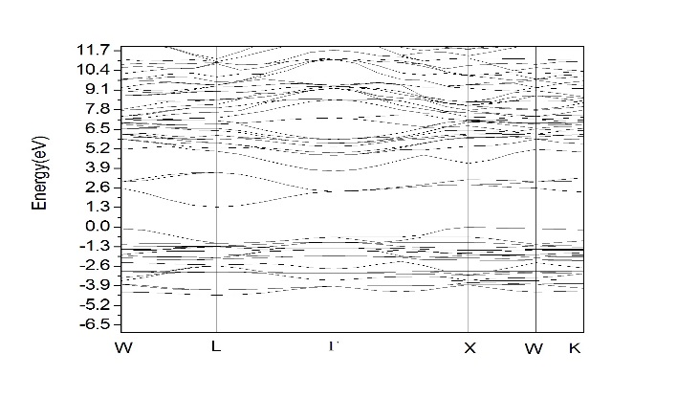
Fig.1. Electronic band structure for Cs₂AgBiBr₆

The optical properties of semiconductors are important physical parameters that are required to model quantum structures [26,27]. Before being absorbed, the incident light of a given wavelength penetrates into a material and travels a certain distance. This distance is characterized by a physical parameter termed as the absorption coefficient [28-30]. Fig. 2 illustrates the evolution of the absorption coefficient as a function of the photon incident energy. Note that the absorption coefficient is practically null for photon incident energies lower than the fundamental absorption edge then it increases in magnitude. This is attributed to the increase of the number of electrons which have the energy that permits them to interact with photons. The magnitude of the optical absorption coefficient depends on that of the electromagnetic waves frequency. As far as the material of interest is concerned, the latter shows a good absorption of light in the visible spectrum region.
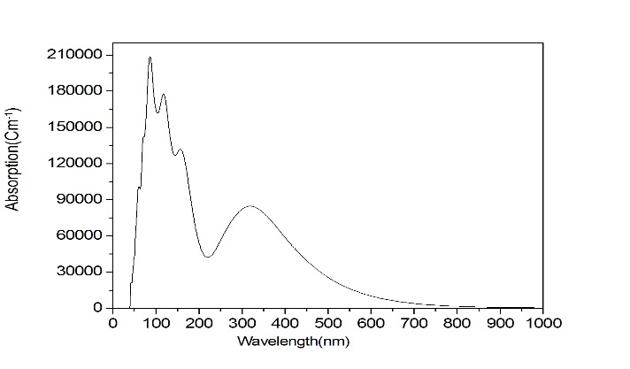
Fig.2. Optical absorption coefficient spectrum for Cs₂AgBiBr₆

- Conclusion
In summary, the electronic band structure and optical properties of Cs₂AgBiBr₆ double perovskite have been investigated using a pseudopotential plane-wave method within the GGA-PBE approach. The material of interest showed a good absorption in the visible spectrum region. However, its fundamental band gap energy was found to be indirect. This suggests that its application in photovoltaics is limited. We propose to replace Bi by In in order to change the nature of the gap. Work is in progress in this regard.
References

[1] A. Kojima, K. Teshima, Y. Shirai, T. Miyasaka, Organometal halide perovskites as visible-light sensitizers for photovoltaic cells, J. Am. Chem. Soc., 131 (2009) 6050-6051, DOI: 10.1021/ja809598r.

[2] R. F. Service, Energy technology. Perovskite solar cells keep on surging, Science 344 (2014) 458 , DOI: 10.1126/science.344.6183.458.

[3] H. J. Snaith, Perovskites: The Emergence of a New Era for Low-Cost, High-Efficiency Solar Cells, J. Phys. Chem. Lett. 4 (2013) 3623-3630, DOI: 10.1021/jz4020162

[4] N. N. Park, Organometal Perovskite Light Absorbers Toward a 20% Efficiency Low-Cost Solid-State Mesoscopic Solar Cell, J. Phys. Chem. Lett. 4 (2013) 2423-2429, DOI: 10.1021/jz400892a

[5] K. T. Butler, J. M. Frost, A. Walsh, Band alignment of the hybrid halide perovskites CH₃NH₃PbCl₃, CH₃NH₃PbBr₃ and CH₃NH₃PbI₃, Mater. Horiz. 2 (2015) 228 and references therein, DOI: 10.1039/C4MH00174E

[6] A. Walsh, Principles of Chemical Bonding and Band Gap Engineering in Hybrid Organic–Inorganic Halide Perovskites, J. Phys. Chem. C 119 (2015) 5755-5760, DOI: 10.1021/jp512420b
[7] Z. Zhang, C. Wu, D. Wang, G. Liu, Q. Zhang, W. Luo, X. Qi, X. Guo, Y. Zhang, Y. Lao, B. Qu, L. Xiao, Z. Chen, Org. Electron. 74 (2019) 204-210, DOI: 10.1016/j.orgel.2019.06.037

[8] L. Schade, A. D. Wright, R. D. Johnson, M. Dollmann, B. Wenger, P. K. Nayde, D. Prabhakaran, L. M. Herz, R. Niclolas, H. J. Snaith, P. G. Radaelli, Toward Lead-Free Perovskite Solar Cells, ACS Energy Lett. 4 (2019) 299-305, DOI : 10.1021/acsenergylett.6b00499

[9] J. Yang, P. Zhang, S. -H. Wei, Band Structure Engineering of Cs₂AgBiBr₆ Perovskite through Order-Disordered Transition: A First-Principle Study, J. Phys. Chem. Lett. 9 (2018) 31-35, doi: 10.1021/acs.jpclett.7b02992.

[10] R. Fu, Y. Chen, X. Yong, Z. Ma, L. Wang, P. Lv, S. Lu, G. Xiao, B. Zou, Pressure-induced structural transition and band gap evolution of double perovskite Cs₂AgBiBr₆ nanocrystals, Nanoscale 11 (2019) 17004-17009, doi: 10.1039/c9nr07030c.
[11] G. Garcia-Espejo, D. Rodríguez-Padrón, R. Luque, L. Camacho, G. de Miguel, Mechanochemical synthesis of three double perovskites: Cs₂AgBiBr₆, (CH₃NH₃)₂TlBiBr₆ and Cs₂AgSbBr_{6 ,} Nanoscale 11 (2019) 16650-16657, DOI:10.1039/C9NR06092H

[12] S. J. Clark, M. D. Segall, C. J. Pickard, P. J. Hasnip, M. J. Probert, M. I. J. Refson, M. C. Payne, First principles methods using CASTEP, Z. Krist. 220 (2005) 567-570, DOI :10.1524/zkri.220.5.567.65075

[13] J. P. Perdew, K. Burke, M. Ernzerhof, Generalized Gradient Approximation Made Simple, Phys. Rev. Lett. 77 (1996) 3865-3868, DOI :https://doi.org/10.1103/PhysRevLett.77.3865

[14] H. J. Monkhorst, J. D. Pack, Special points for Brillouin-zone integrations,
Phys. Rev. B 13 (1976) 5188-5192, DOI:https://doi.org/10.1103/PhysRevB.13.5188
[15] N. Bouarissa, Optoelectronic properties of InAs 1− x P x semiconducting alloys,
- Mater. Sci. Eng. B 86 (2001) 53, DOI: 10.1016/S0921-5107(01)00658-4
[16] M. L. Cohen, J. R. Chelikowsky, Electronic Structure and Optical Properties of Semiconductors, Berlin: Springer-Verlag, 1989
[17] N. Bouarissa,Electron and Positron Energy Levels and Deformation Potentials in Group‐III Nitrides, Physica Status Solidi B 231 (2002) 391, doi: 10.1002/1521-3951(200206)231:2<391::AID-PSSB391>3.0.CO;2-J

[18] A. Bechiri, F. Benmakhlouf, N. Bouarissa, Band structure of III–V ternary semiconductor alloys beyond the VCA, Mater. Chem. Phys. 77 (2003) 507, doi: 10.1016/S0254-0584(02)00124-4
[19] R. M. Martin, Electronic Structure: Basic Theory and Practical Methods, Cambridge Univ. Press, 2004

[20] N. Bouarissa, Pressure dependence of optoelectronic properties of GaN in the zinc-blende structure, Mater. Chem. Phys. 73 (2002) 51, doi: 10.1016/S0254-0584(01)00347-9
[21] I. Vurgaftman, J. R. Meyer, L. R. Ram-Mohan, Band Parameters for III-V Compound Semiconductors and Their Alloys,J. Appl. Phys. 89 (2001) 5815, doi:10.1063/1.1368156
[22] S. Adachi, Properties of Semiconductor Alloys: Group-IV, III-V and II-VI Semiconductors, Chichester: John Wiley & Sons Ltd., 2009
[23] N. Bouarissa, F. Annane, Conduction-and valence band offsets of Zn 1-x Mg x Se/Zn 1-y Mg y Se heterointerfaces,Mater. Sci. Eng. B 95 (2002) 100, DOI: 10.1016/j.physb.2018.05.019

[24] N. Bouarissa, Effects of compositional disorder upon electronic and lattice properties of Ga_{x}In_{1−x}As, Phys. Lett. A 245 (1998) 285, doi : 10.1016/S0375-9601(98)00403-4
- [25] L. Hannachi, N. Bouarissa, Band parameters for cadmium and zinc chalcogenide compounds, Phys. B 404 (2009) 3650, DOI: 10.1016/j.physb.2009.06.046

[26] F. Mezrag, W. Kara Mohamed, N. Bouarissa, The effect of zinc concentration upon optical and dielectric properties of Cd_{1-x}Zn _{x}Se, Phys. B 405 (2010) 2272-2276, DOI:10.1016/j.physb.2010.02.024
[27] S. Saib, N. Bouarissa, P. Rodriguez-Hernández, A. Muñoz, Structural and dielectric properties of AlN under pressure, Physica B403 (2008) 4059-4062, DOI:10.1016/j.physb.2008.08.007
[28] S. Djaili, A. Gueddim, A. Guibadj, N. Bouarissa, Temperature dependence of the optical properties of MgO: Ab initio molecular dynamics calculations, Optik 200 (2020) 163421,DOI: https://doi.org/10.1016/j.ijleo.2019.163421

[29] A. Bouarissa, A. Gueddim, N. Bouarissa, S. Djellali, Band structure and optical properties of polyaniline polymer material, Polym. Bull. 75 (2018) 3023, DOI:10.1007/s00289-017-2189-6
[30] A. Khaldi, N. Bouarissa, L. Tabourot, First-Principles Study of Pressure Dependence of Optical Spectra of MnS, J. Supercond. Nov. Magn. 31 (2018) 1643-1647, DOI: https://doi.org/10.1007/s10948-017-4377-x

