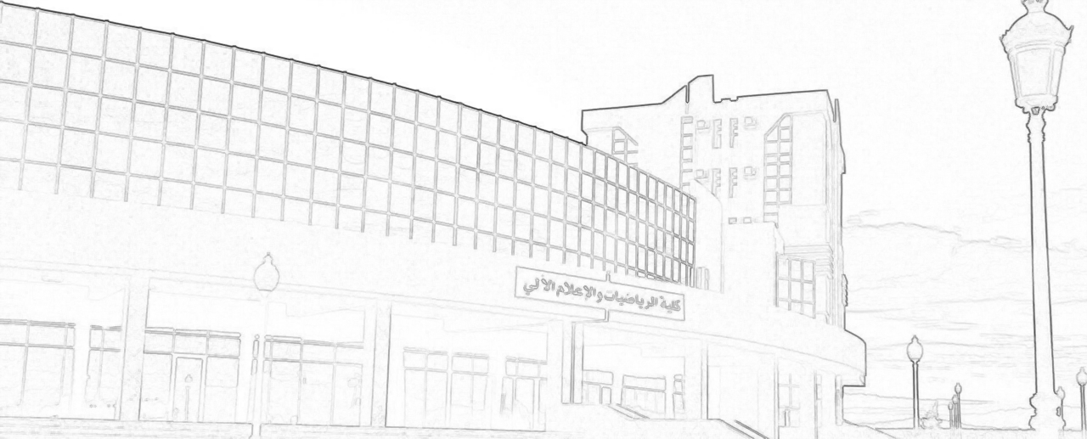

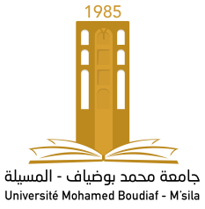

7th M’sila Conference on Mathematical Analysis
M’sila, November 16, 2022

University of Mohamed Boudiaf – M’sila
Faculty of Mathematics and Informatic
Laboratory of Functional Analysis and Geometry of Spaces (LFAGS)

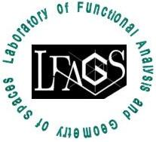
This is to certify that
Certificate of Participation

7th M’sila Conference on Mathematical Analysis
November 16, 2022

Bochra GHERIBI, University of M’sila
has participated in the 7th M’sila Conference on Mathematical Analysis
(7th MCMA 2022) and presented a communication entitled:
On The Hirschmann Theorem with Bessel-Potential Spaces

This work is joint with Madani MOUSSAI of the University of M’sila Head of Laboratory

