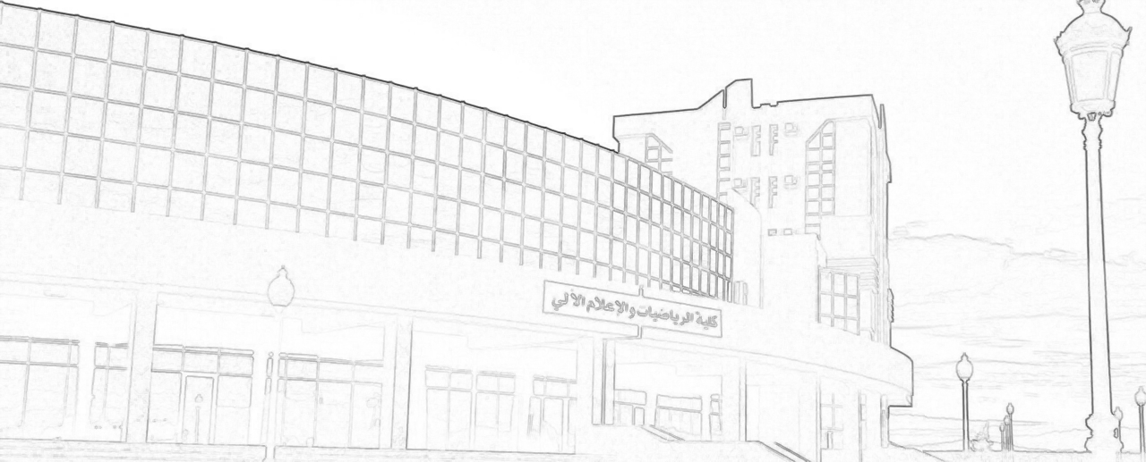

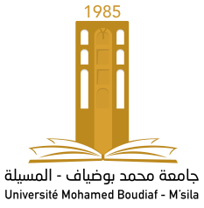
Certificate of Recognition

7th M’sila Conference on Mathematical Analysis
M’sila, November 16, 2022

University of Mohamed Boudiaf – M’sila
Faculty of Mathematics and Informatic
Laboratory of Functional Analysis and Geometry of Spaces (LFAGS)

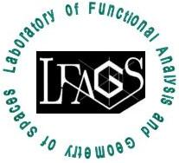
Awarded to
7th M’sila Conference on Mathematical Analysis
November 16, 2022

Madani MOUSSAI
for his contributions as a Member of the scientific committee of 7th M’sila Conference on Mathematical Analysis (7th MCMA 2022)

Head of Laboratory

