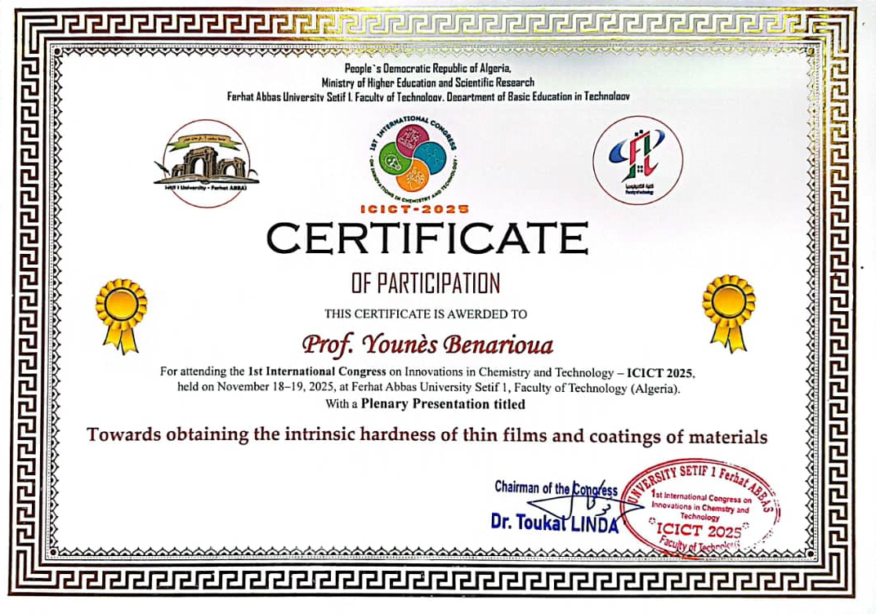


Towards obtaining the intrinsic hardness of thin films and coatings of materials
Younès Benarioua 1, 2
¹ D.G.M, Faculté de Technologies, Université de M’sila,- M'sila 28000, Algérie.
² URME, Université de Sétif 1-19000, Algérie
younes.benarioua@univ-msila.dz, benariouayounes@yahoo.fr

Abstract
Considerable research has been conducted to increase the hardness of the surface area of ​​mechanical parts to enhance the performance of materials subject to surface damage under aggressive conditions. Obtaining the surface areas of these materials can be achieved by implantation treatment, deposition of thin films, coatings and re-enforcing using compatible methods and techniques. The objective of designing films with optimal mechanical properties cannot be achieved without the most accurate determination of their hardness. Unfortunately, direct measurement of film hardness using conventional micro-hardeners is impossible for a wide range of indentation loads, because under these loads the substrate undergoes part of the plastic deformation during the indentation process. It is often assumed that this phenomenon, which involves both materials, begins to be noticeable for loads such that the indentation depth exceeds one tenth of the film thickness. In this case, the HC hardness index, calculated from the measurements, therefore results from the contribution of both the substrate and the film. In order to determine the absolute hardness of film and coating, it is necessary to separate the substrate contribution. It is known that, depending on the thickness of the film and on the applied load, indentation measurements give apparent hardness values which are the results of contributions by both the substrate and the film. There is a need therefore to separate these two contributions in order to determine the true hardness of the film or coating. Numerous authors have worked on this subject during the past and a large number of models who are written under an additive linear function are available in the literature. This study is to determine the absolute hardness of certain films and coatings of various materials deposited on several materials by applied different models. These mathematical models can be grouped into two kinds of models which called monolayer and multilayers models.

